Study the effect of *Marrubium vulgare* total extract on MPO activity in carrageenan induced paw edema in rats.

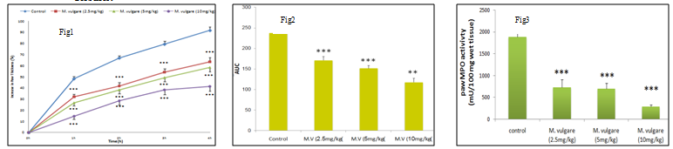**Samira Asghari, Fatemeh Fathi Azad, Nasrin Maleki Dizaji.**

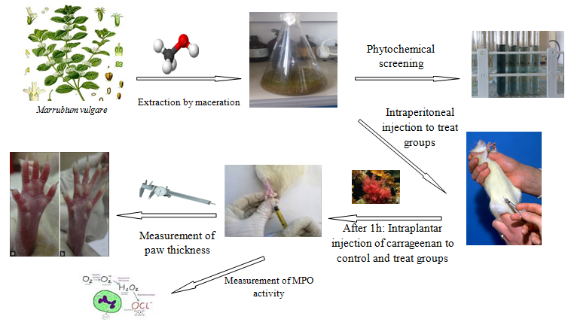

Method

Results

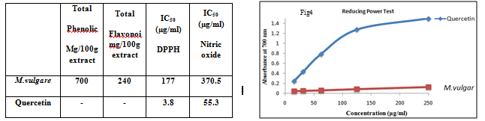

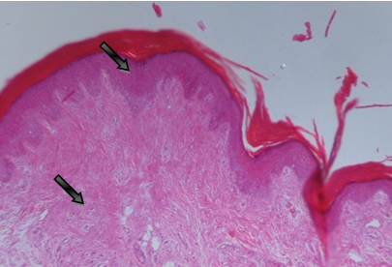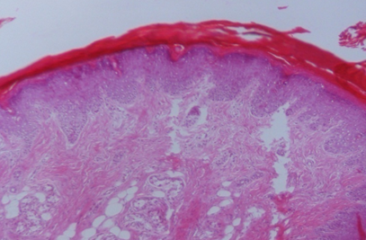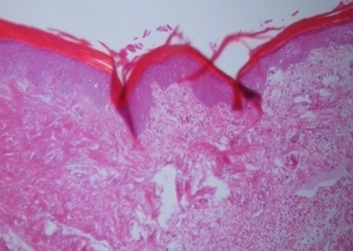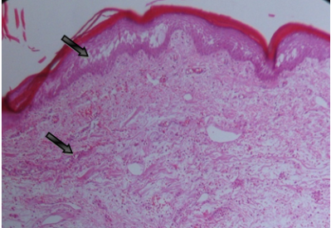

control

10mg/kg extract

5mg/kg extract

2.5mg/kg extract

**Conclusion**

According to data that are presented here, the extract has a strong anti inflammatory effects which could be related to its antioxidant properties by inhibition of leukocyte infiltration.